EXPT NO:4 | Visual encoding of data
DATE: 20.01.2026 | Visual encoding of data

PRE-LAB QUESTIONS

1. How does the human visual system process visual variables?
The human visual system prioritizes pre-attentive features—things like color, size, position, and shape are processed almost instantly, before conscious thought. Position and length are perceived most accurately. Color hue, shape, and area are weaker and more error-prone. If you encode critical data using weak variables, you’re fighting biology—and you’ll lose.

2. Why is improper encoding misleading in analytics?
Because it creates false patterns or hides real ones. Bad encoding exaggerates minor differences or downplays major ones, leading viewers to draw incorrect conclusions. That’s not a design issue—that’s a decision-making failure. In analytics, misleading visuals are worse than no visuals at all.

3. What are perceptual limitations in visualization?
Humans:
- Struggle to compare areas and volumes accurately
- Can’t distinguish many similar colors
- Get overloaded beyond ~5–7 visual categories
- Miss patterns in cluttered visuals
Ignoring these limits guarantees misinterpretation, no matter how “advanced” the AI behind it is.

4. How does color choice affect interpretation?
Color implies meaning whether you like it or not. Red signals danger, blue implies calm, green suggests safety. Poor color choices can:
- Create emotional bias
- Hide differences
- Exclude color-blind users
Color should encode meaning, not decorate charts.

5. Why should AI dashboards be perceptually optimized?
Because users don’t trust or act on what they don’t understand. If insights aren’t immediately visible, the AI might as well not exist. Poor perception kills explainability, adoption, and decision impact. Optimization isn’t optional—it’s foundational.

OBJECTIVE: To apply effective visual encoding principles for meaningful data communication.
SCENARIO: A city traffic department analyzes accident data to identify high-risk zones and accident severity patterns.
IN-LAB TASKS (Using R Language) • Encode severity using color gradients • Represent accident frequency using size • Use shape to indicate accident type

CODE:
library(ggplot2)
# Load dataset
accidents <- read.csv("4.traffic_accidents.csv")
# Convert Accident_Type to factor
accidents$Accident_Type <- as.factor(accidents$Accident_Type)
# Convert Severity to ordered factor
accidents$Severity <- factor(
accidents$Severity,
levels = c("Minor", "Serious", "Fatal"),
ordered = TRUE
)
# Create frequency per location
acc_freq <- aggregate(
Accident_ID ~ Location + Severity + Accident_Type,
data = accidents,
FUN = length
)
colnames(acc_freq)[4] <- "Frequency"
# Plot
ggplot(acc_freq, aes(x = Location, y = Frequency)) +
geom_point(
aes(
color = Severity,
size = Frequency,
shape = Accident_Type
),
alpha = 0.7
) +
scale_color_manual(
values = c("Minor" = "yellow", "Serious" = "orange", "Fatal" = "red")
) +
scale_size_continuous(range = c(3, 10)) +
labs(
title = "Accident Severity and Frequency by Location",
x = "Location",
y = "Accident Frequency",
color = "Severity",
shape = "Accident Type"
) +
theme_minimal()
# Roll number at end
my_roll_no <- "23BAD109"
print(paste("Lab completed by roll number:", my_roll_no))

OUTPUT:

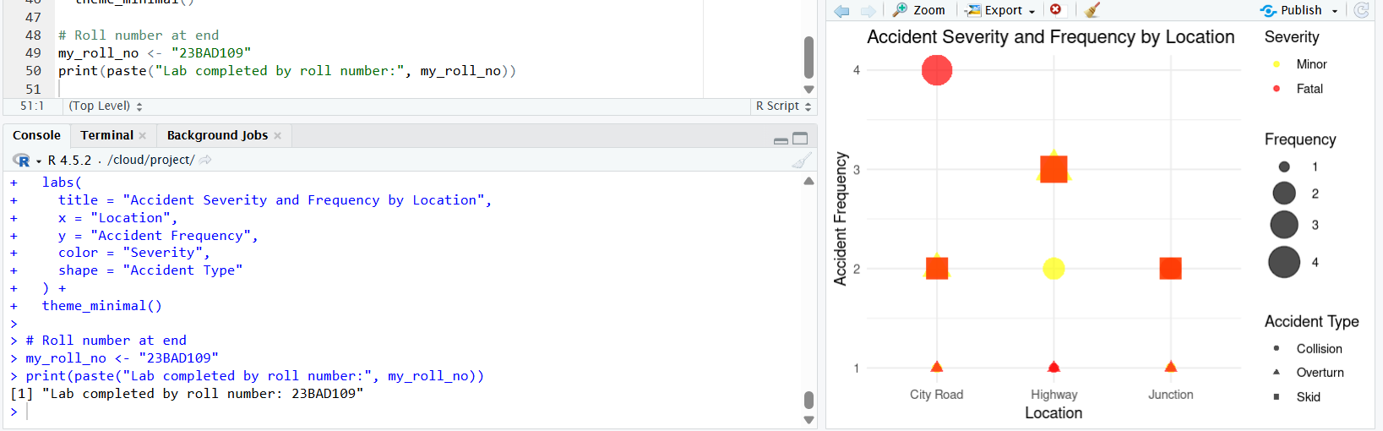

POST-LAB QUESTIONS
1. Which visual variable best conveys severity and why?
Color intensity best conveys severity because it is processed pre-attentively by the human visual system. A light-to-dark color gradient naturally represents increasing magnitude, allowing users to quickly identify high-severity accidents without conscious effort.
2. How can poor encoding mislead policy decisions?
Poor visual encoding can hide critical high-risk zones or exaggerate insignificant patterns. This can lead policymakers to allocate resources incorrectly, underestimate accident severity, or implement ineffective safety measures, resulting in real-world consequences.
3. What precautions should be taken for color-blind users?
Color-blind-safe palettes should be used, avoiding red–green combinations. Redundant encodings such as size, shape, or labels should be added so information is not conveyed by color alone.
4. How does visual encoding affect AI explainability?
Visual encoding determines how clearly AI-generated insights are understood. Effective encoding exposes patterns and relationships detected by AI, while poor encoding obscures logic and makes AI outputs appear opaque or untrustworthy.
5. Suggest improvements for large-scale public dashboards.
Large-scale public dashboards should minimize clutter, maintain consistent visual encodings, support filtering and zooming, and include brief annotations in simple language to guide interpretation for non-technical users.

ASSESSMENT
Description | Max Marks | Marks Awarded
Pre Lab Exercise | 5
In Lab Exercise | 10
Post Lab Exercise | 5
Viva | 10
Total | 30
Faculty Signature

